Name: Veeransh Shah

221070063

VJTI (COMPS)

Batch C

**Aim:**

Write a program in a python to perform CRUD operations on database(sqlite3/MYSql)

CRUD stands for Create, Read, Update, and Delete, which are the basic operations used to manage

data in a database.

Let's break down the theory behind CRUD:

**1. Create:**

- The Create operation involves adding new data records or entries into the database. It typically

corresponds to the SQL `INSERT` statement, where new rows of data are added to a table.

**2. Read:**

- The Read operation involves retrieving or fetching data from the database. It corresponds to the

SQL `SELECT` statement, which allows you to query the database and retrieve specific information.

**3. Update:**

- The Update operation is used to modify existing data records in the database. It corresponds to

the SQL `UPDATE` statement, allowing you to change the values of one or more columns in existing

rows.

**4. Delete:**

- The Delete operation is used to remove data records from the database. It corresponds to the

SQL `DELETE` statement, which removes specific rows from a table based on certain conditions.

In the Python example provided earlier, these CRUD operations are implemented using SQLite, a

lightweight database engine. Here's how each operation is implemented:

- Create: The `create_user` function uses an `INSERT` SQL statement to add new user data (name

and email) into the `users` table.

- Read: The `read_users` function performs a `SELECT` query to fetch all user records from the

`users` table and displays them.

- Update: The `update_user_email` function modifies the email of a specific user by using an

`UPDATE` SQL statement.

- Delete: The `delete_user` function removes a specific user record from the `users` table using the

`DELETE` SQL statement.

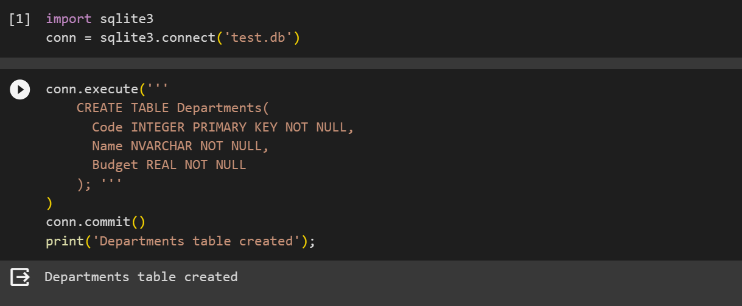

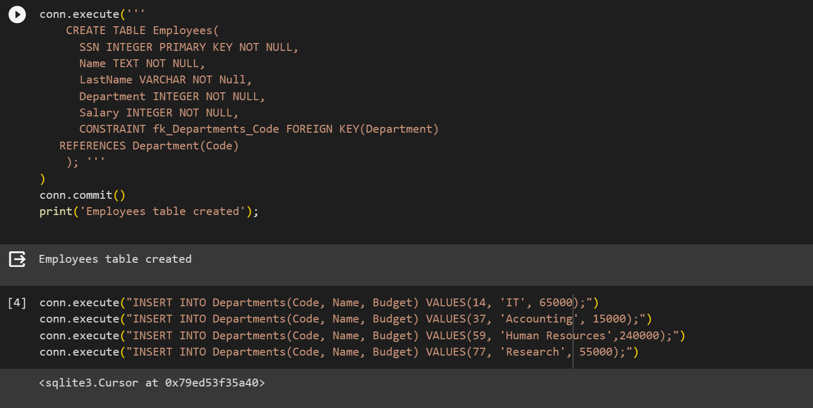

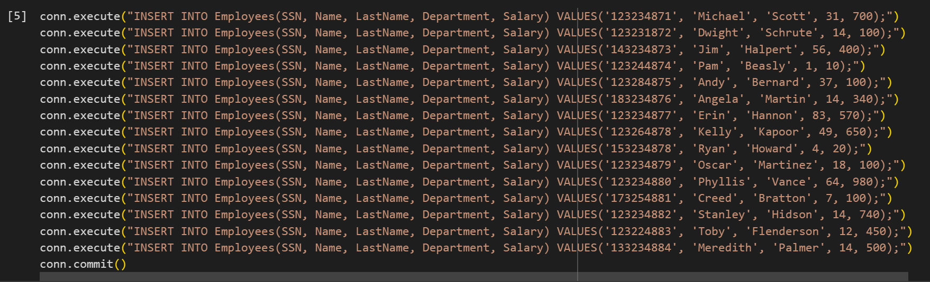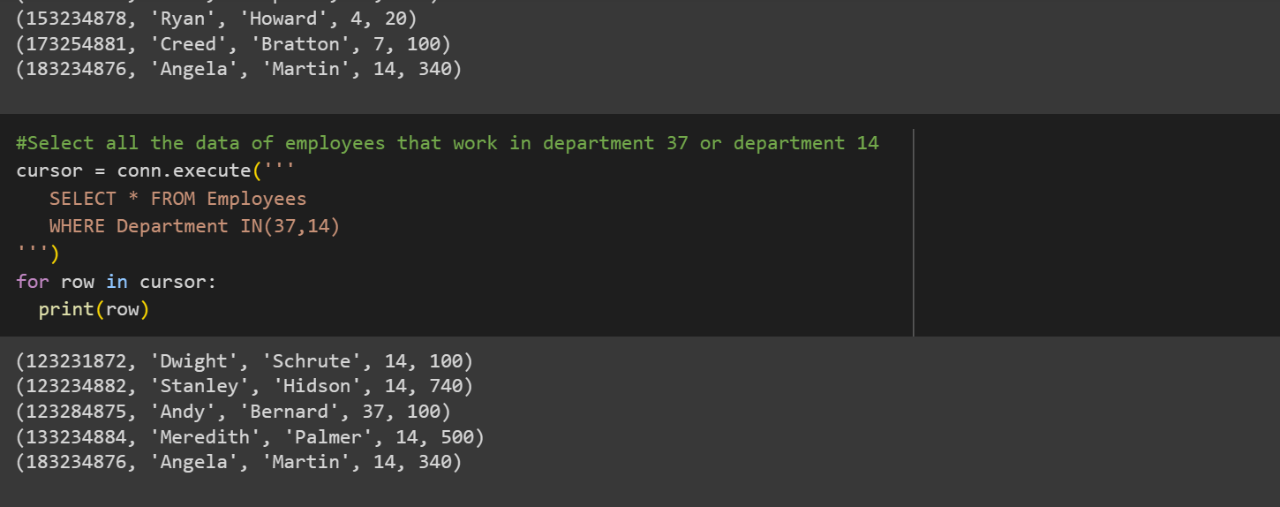

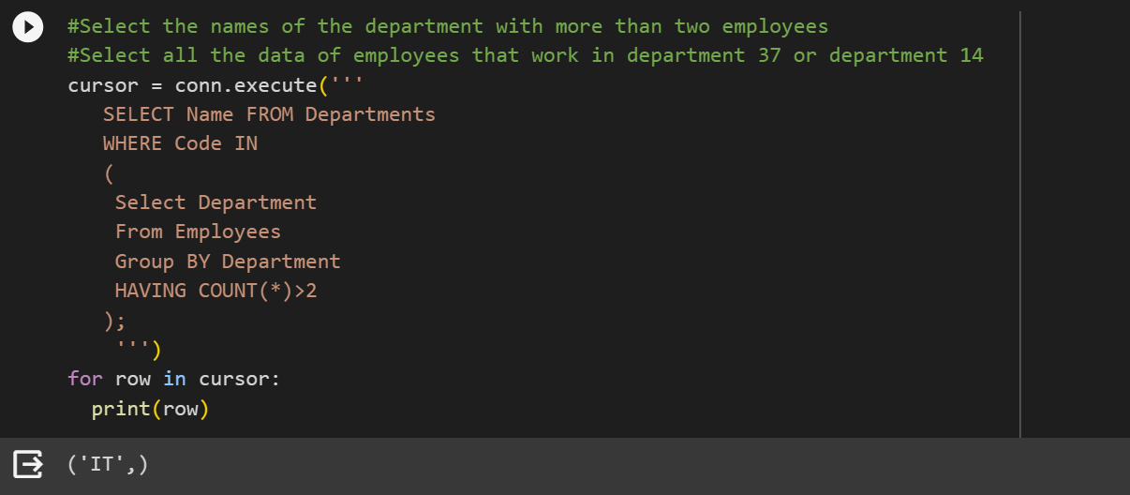

**Conclusion:**

We got to know about CRUD operations using sqlite3 db